* Extends vs. Implements CSC EXAM 1
  + 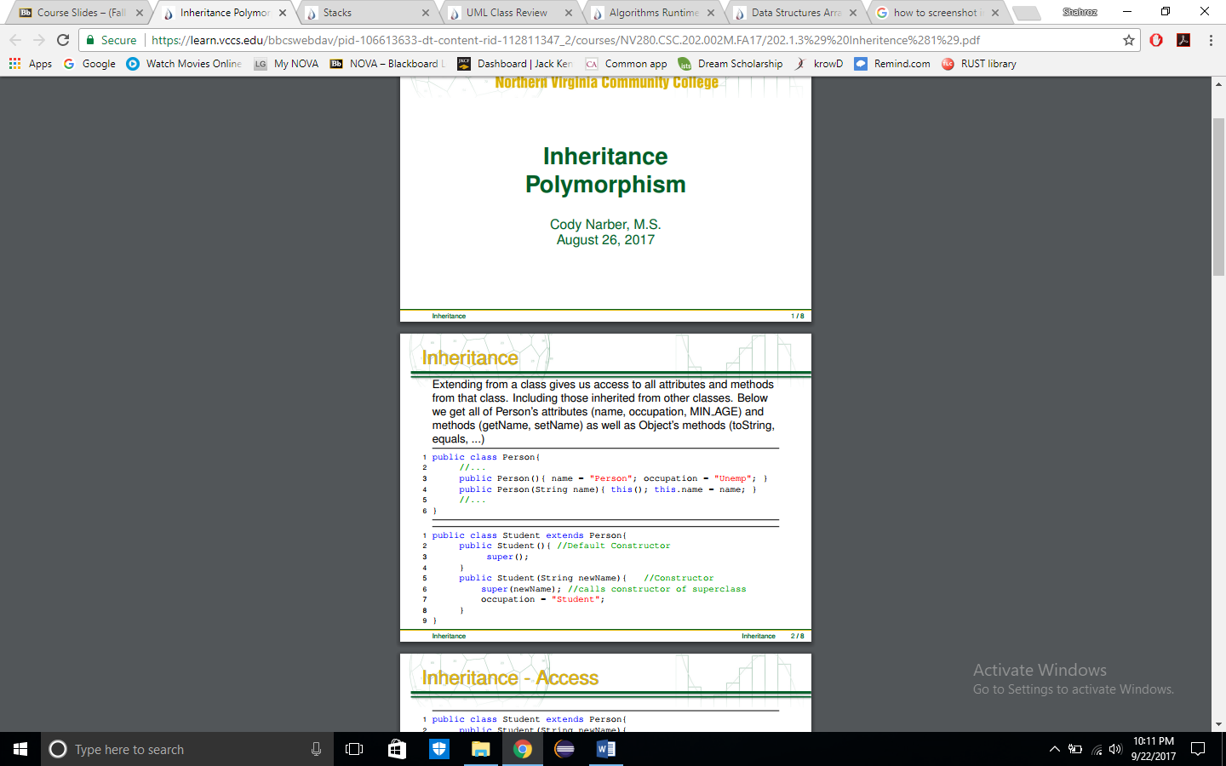
* I Inheritance & Polymorphism
  + 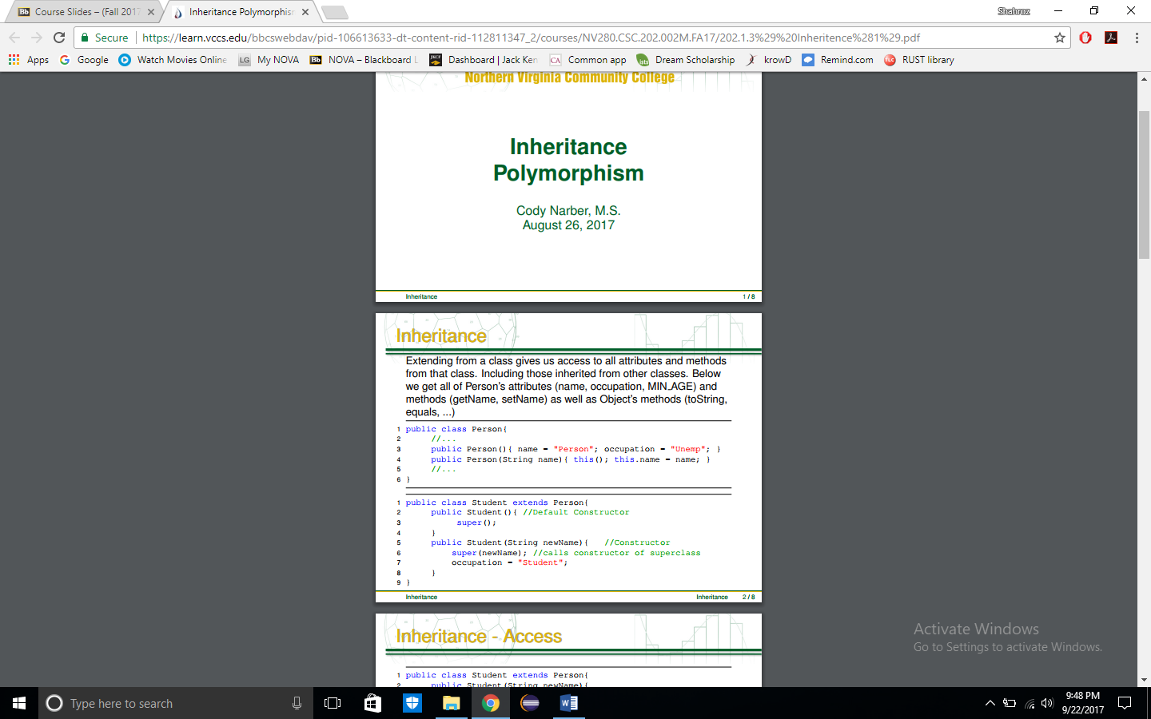
  + 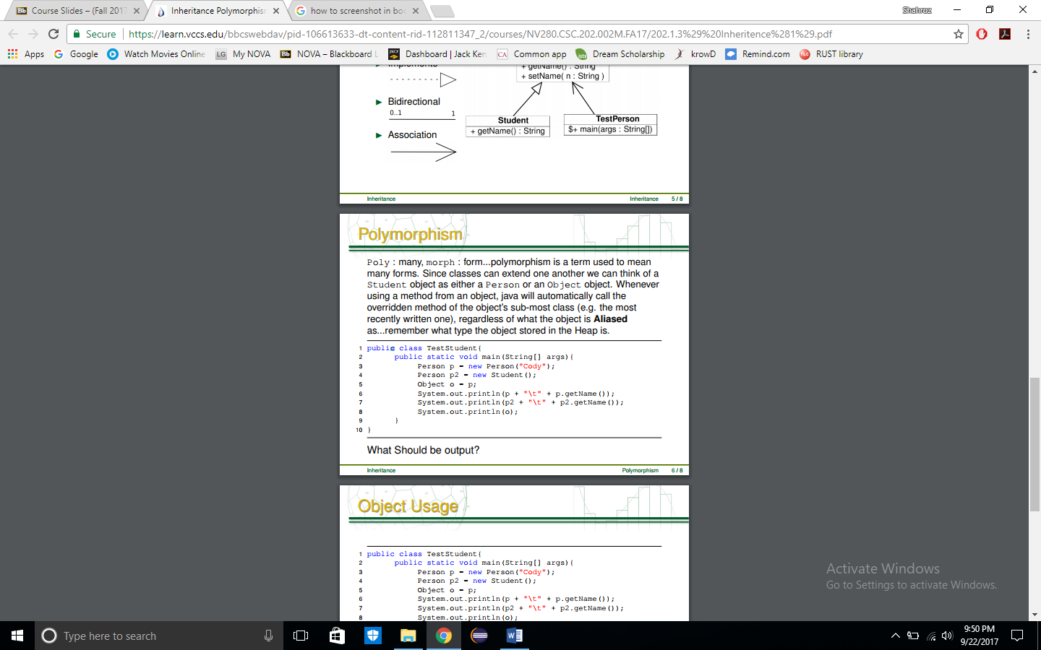
* I Override vs. Overwrite
  + 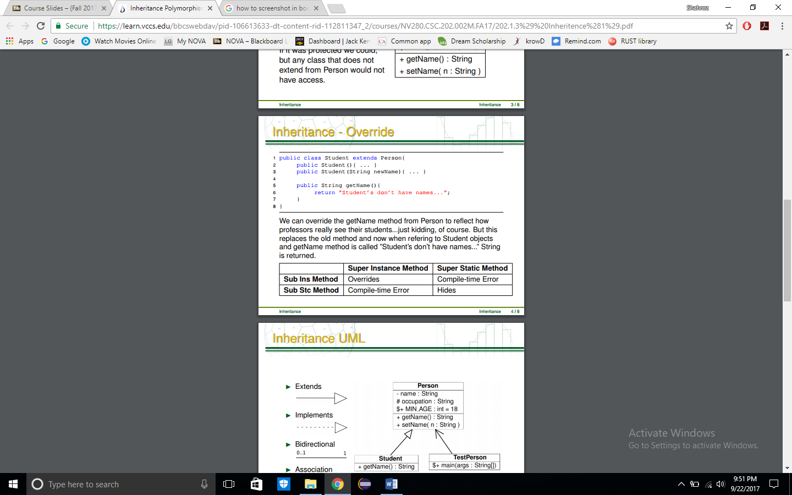
* I Abstraction vs. Information Hiding vs Encapsulation
  + 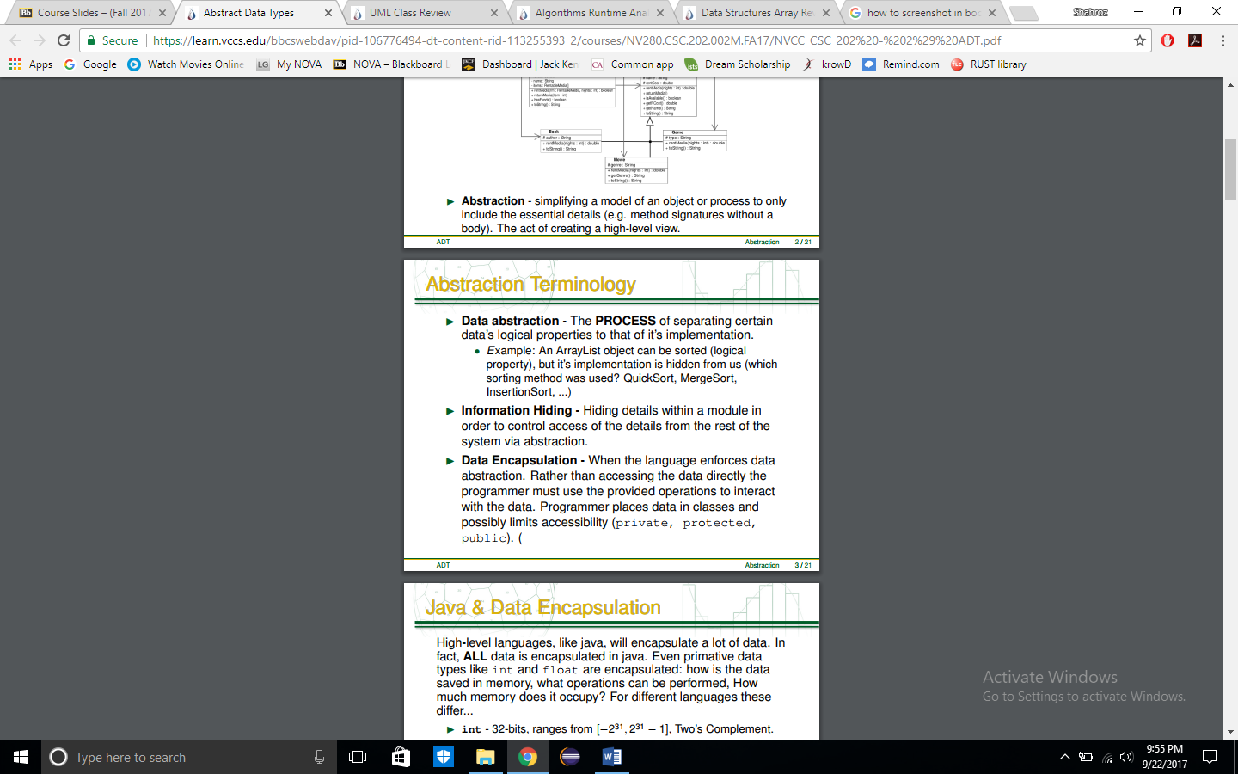
* I Perspectives of ADTs (Application/Logical/Implementation)
  + 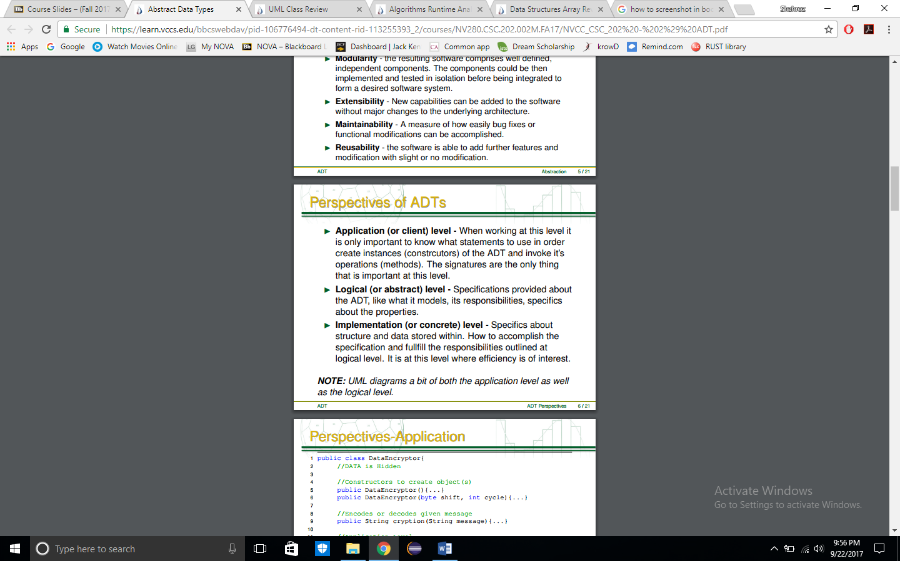
* I Preconditional vs Post conditionals
  + 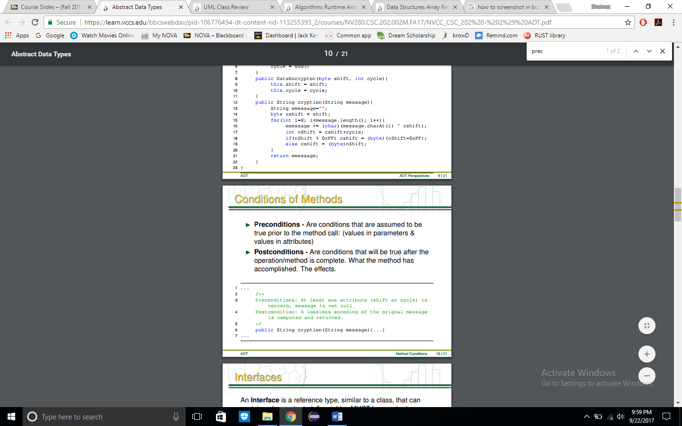
* I UML Diagrams
  + 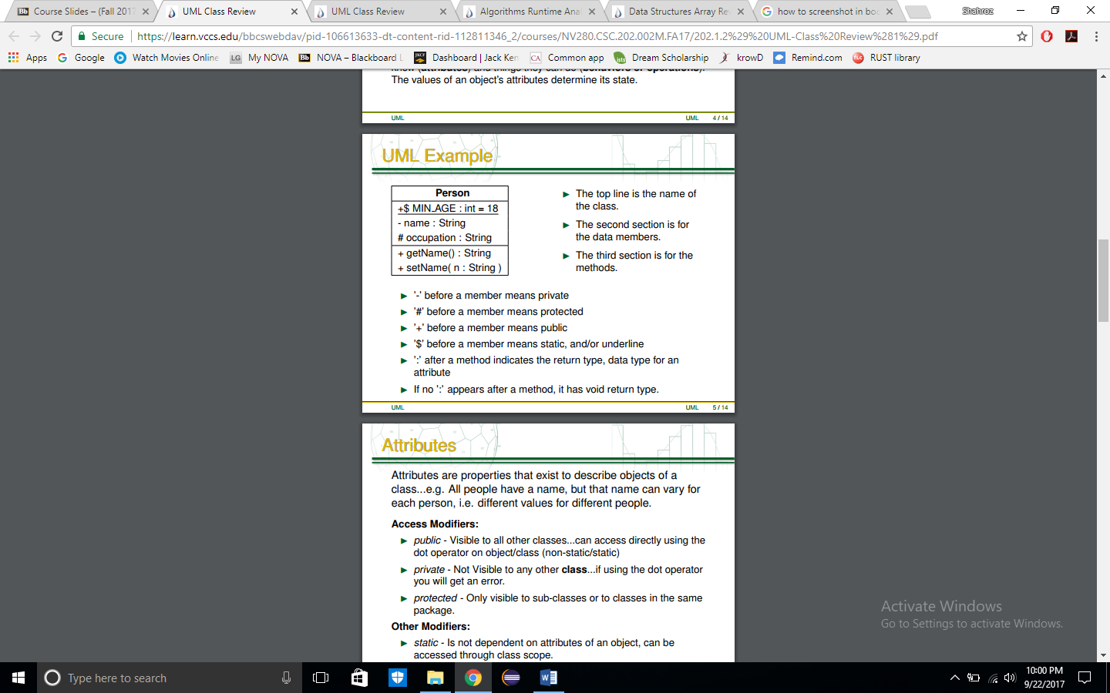
  + 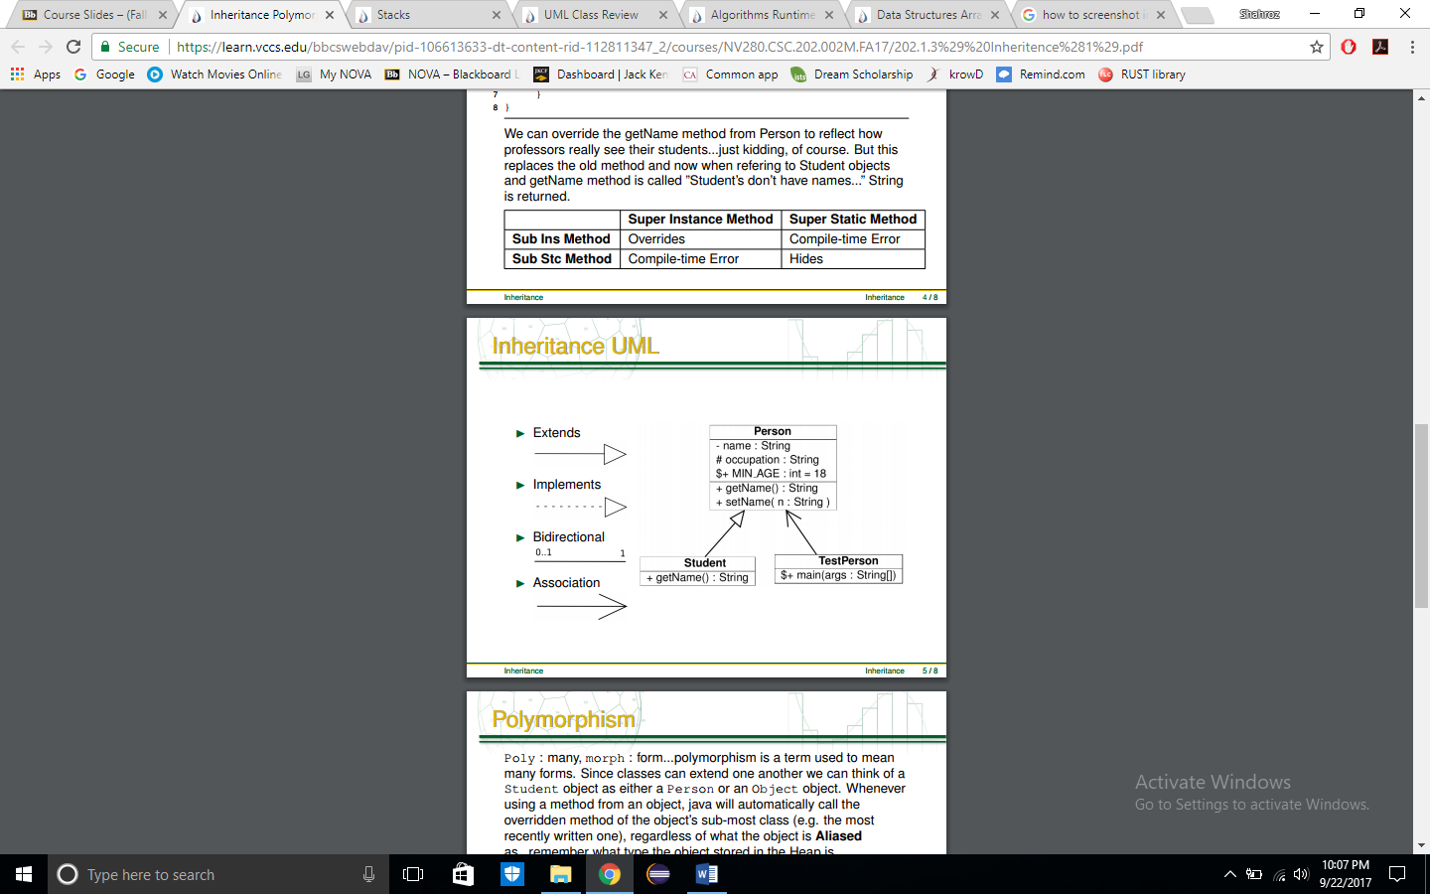
* I Reference vs. Value
  + 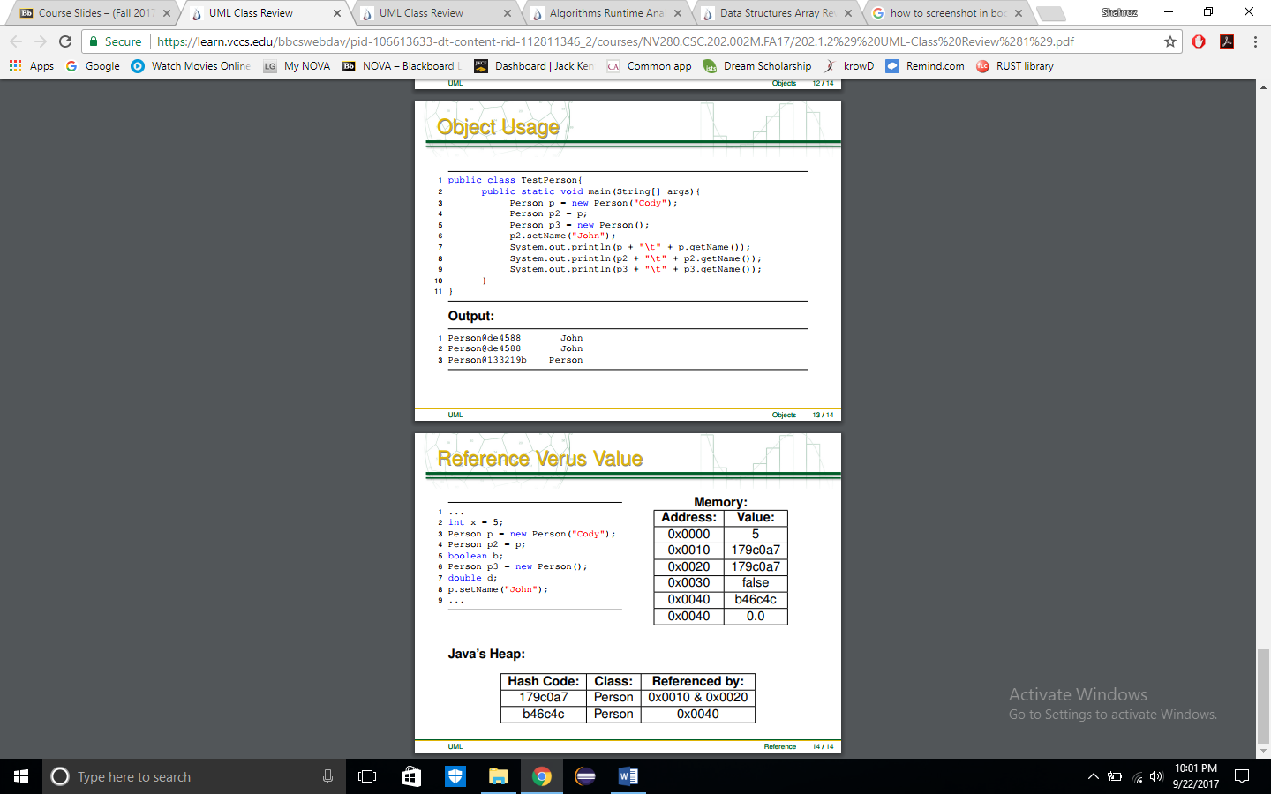
* I Run-time Analysis
  + 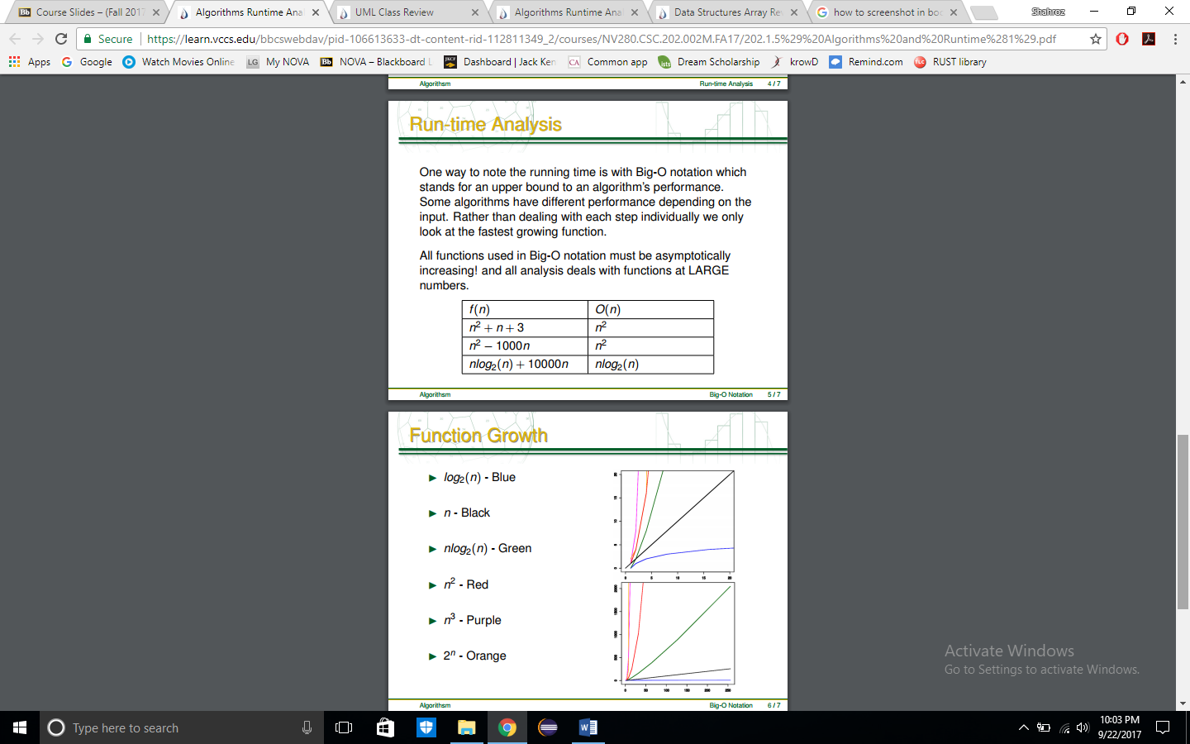
* I Stacks - operations